Chapter 2

**Materials and Methods**

This section discusses the activities, methods and materials used in the design and development of a Computer-Based Class and Program Scheduling System that will help teachers in creating schedules of classes regarding time, subject , section and name of the teacher handling that specific class.

The researchers underwent planning and research in developing the system. It include the data entry about schedule, saving the data, detection of conflicting schedules and printing of schedules and related data.

**A. Acquisition of Components**

The system was developed using the combination of software and hardware. The researchers used a computer programming language to design the interface of the system and its functionalities. Through research, the researchers were able to find resources which they used for creation of the system.

**B. Software Requirements**

The system was developed using a computer programming language under the Microsoft Visual Studio on a windows 7 platform. It also uses a database to store information inserted via the system. The user of the system can add new record of teachers, set class schedules, room assignments and print reports if needed. The system can be installed in a computer running under the windows 7 or 8.

**C. Hardware Requirements**

A computer, specifically a laptop unit was used in the development of the system. It is where the programming language was installed and the operating system also. It was a good choice because of its transferability and it is lightweight. The researchers can take it along with them wherever they may go.

**Figure 1**

**Laptop Unit**

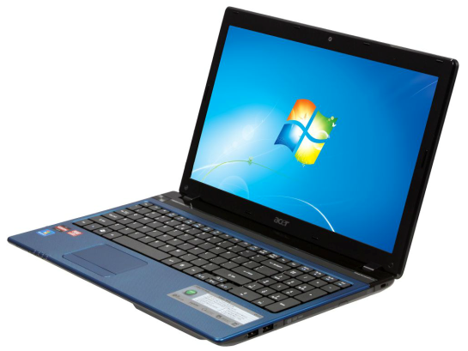

Though the system was developed using a laptop unit, it can also be installed using a desktop unit, although it lack mobility compared to a laptop. In comparison to processing, a desktop can have more power due to its easy assembly and disassembly when in need of peripheral replacement or adding more resources like memory, something that can’t be always done to a laptop.

**Figure 1**

**Desktop Unit**

